The **value** is **morality** as implied by the resolution. In order to guide action, a moral system must explain not only what is moral but also why those moral facts have motivational force. Gregory **Strom**[1] writes

Now, the “ought-ought gap” is our fanciful term for a mental ailment in which one knows that there is some reason such that any good person would respond to it by doing A, but in which one does not know what that reason is. But this way of formulating the problem obscures a great many issues, for if we consider any particular case in which **someone** wrestles with the ought- ought gap, it is clear that she **may know a great deal about the reason to do A and nonetheless fail to understand why she ought to do it. Anyone who says**, for example, something like “**I know I should return the money—but if I don’t, no one will ever know** I acquired it, and I won‘t get into any trouble **so why should I do it?” is not entirely in the dark about the reasons that there are to return the money.** We can even imagine her able to supply herself with a demonstration, grounded in secure a priori principles about (say) the concept of property, that morality requires her to return this money, and nonetheless unable to understand why she should return it. This shows that what someone in such a fix really needs is not merely to appreciate that a good person would return the money because of such-and-such a reason. For this can appear to her merely as an alien fact having nothing to do with her. **What is really needed, therefore, is for her to recognize these facts as having to do with her.** That is, she must relate herself to the concept of a good person in such a way that, for her, recognition that a good person returns the money for such-and-such a reason is the same thing as practical recognition of the rational force of this reason that manifests itself in her returning the money. **In other words,** not only must she learn to refine her concept of a good person to the point where it is adequate to her situation, but also **she must think of herself as a good person**; she must learn to think of herself as primarily or essentially what she learns about when she learns about good people.

Only virtue ethics meet this requirement. We act morally because we think of ourselves as virtuous people. If we did not aspire to be virtuous, we would have no reason to follow moral demands.

Jason **Kawall 09** writes[2]

**One** of the **major problem**s **that ethical theories face** today **is to determine the** precise **connection between** the **recognition of ethical dilemmas** by a moral agent **and** his subsequent **motivation to act.** Frequently, philosophers argue, it is not enough for a moral agent to know ethical principles that apply only to universalized situations; something else has to occur for the agent to truly jump into gear. Simply knowing theoretical ethical principles does not provide the agent with the fine-tuned perception necessary to actually recognize a specific situation as deserving of action. This is one of the reasons why rule-based systems of ethics are problematic, as they already assume that the moral agent has discerned ethical salience in a given situation. However, that is not necessarily the case. In other words, knowing that “one should be benevolent to those less fortunate” does not give any specific information as to what action to take when one is faced with a homeless person on the street, for instance. In such a situation, one first has to recognize that the other person has a good of his or her own, is in need, and thus deserving of help. In the same way, the rule does not provide information regarding what form the aid should take: should one simply give the person money for food? Or should one try to help in more profound ways, such as finding him or her a job etc.? All these scenarios already depend on the moral perception of the moral agent; that is, the situation first has to be perceived to be a moral one, for otherwise moral activity is not at all required. As Blum puts it: The point is that perception occurs prior to deliberation, and prior to taking the situation to be one in which one needs to deliberate. It is precisely because the situation is seen in a certain way that the agent takes it as one in which he feels moved to deliberate. 40 Therefore, the significance of moral perception for subsequent action is undeniable. The question now becomes: What is moral perception and how does it develop in a moral agent? Clearly, rules and regulations in and by themselves are not guides to moral perception, since they only prescribe how to act once a moral situation is already perceived as requiring action. **Therefore, deontological and utilitarian theories** of ethics generally **begin too far down the road, as they already presuppose the moral perception of the** moral **agent.** The principles provided can only be applied if the situation has been recognized as a moral one. **However, moral perception appears to be a component of the characteristics** and dispositions **of a person, as they are** an integral **part of how a person** dwells in and **interacts with the world. Thus, moral perception**, which is essential and prior to any moral judgment, **is closely linked to** ethical theories of **virtue, as the virtues** are generally regarded to **shape an agent’s understanding of** his or **her moral environment.**

Therefore the criterion is **fostering virtue**.

Fostering virtue requires role models. Therefore, a moral agent ought to emulate virtuous people. Rebecca **Carhart 09** writes[3]

Another strength of virtue ethics is that it emphasizes the development of personal character through the teaching and practice of virtues. A key component of this process is the imitation of individuals who are recognized as examples of virtuous character. A pacifist would thus emphasize studying the lives of figures recognized for their peace-promoting standards in order to develop the same positive traits as those people. Different individuals may be upheld as examples of different virtues, and the same may be true for vices. According to William Frankena, the recognition of a moral ideal is critical in motivating one to be a certain kind of person (1993). One interesting implication of these concepts is a high valuation of history, art, and other disciplines that offer insight into human character. Considerations of particular people and whole societies may lead to an understanding of how actions are shaped by character and values, knowledge that is valuable in making practical decisions.

I **contend** that virtuous figures would promote the norm of pacifism.

Craig **Ihara 78** writes[4]

But even if we suppose that this type of pacifist can and does hold the three beliefs stated above, this does not necessarily distinguish him, I think, from ordinary moral individuals. If they in fact disagree, it is likely that it will be with regard to 3. But in this the fact that those we all consider to be saintly men, for example, Gandhi, Gotama Buddha, and Jesus Christ, are usually thought to be pacifists provides some grounds for maintaining that we are in basic agreement with the pacifist on 3 as well as on 1 and 2. In other words, the fact that those we consider to be paragons of virtue we [are] also consider to be pacifists indicates that we generally concur in the belief that lives of nonviolence are morally better than the lives of the average moral individual. Whether we would persist in this belief upon careful reflection is a matter I will not take up here.

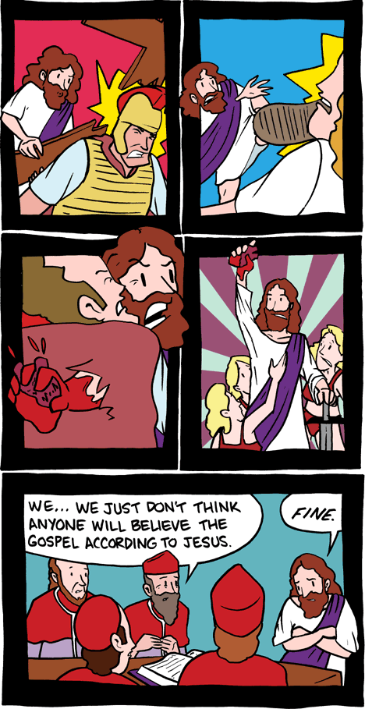

1. Gregory Strom. In Defense of the Practical Imagination. University of Pittsburgh. No date. http://www.pitt.edu/~gbs4/In%20Defense%20of%20the%20Practical%20Imagination.pdf
2. “In Defense of the Primacy of Virtues,” Jason Kawall. Journal of Ethics and Social Philosophy. Vol 3, Num. 2. 2009.
3. Carhart, Rebecca (Philosophy Major @ Taylor University). “Pacifism and Virtue Ethics.” LYCEUM. Volume XI, No. 1 (Fall 2009)<http://lyceumphilosophy.com/?q=node/126>
4. Ihara, Craig K (Fullerton State University). “In Defense of a Version of Pacifism.” Ethics, Vol. 88, No. 4 (July 1978), pp. 369-374. Published by The University of Chicago Press. Accessed: 29/12/2011 01:40 http://www.jstor.org/stable/2380243